Monitoring and Securing the DFI Environment Introduction

Project Overview
Douglas Financials Inc (DFI from here forward) has experienced successful growth and, as a result, is ready to add a Security Analyst position. Previously Information Security responsibilities fell on our System Administration team. Due to compliance and the growth of DFI, we are happy to bring you on as our first InfoSec employee! Once you are settled in and finished orientation, we have your first 2-Weeks assignments ready.
- Week 1: Your first set of tasks is to perform an analysis of Windows server using Defense in Depth principles, as well as the concept of Least Privilege, and provide a report with recommendations on OS hardening, compliance issues, encryption, and network security.
- Week 2: You'll next be asked to recommend mitigation steps from your analysis of firewall reports (and new connections) in the form of creating sample firewall rules. Similarly, you'll analyze threat intelligence and craft sample IDS signatures. You'll also encrypt several files and folders in preparation for transport to a client.
More details to follow in the template document, which you can find on the next page.

Download the project files

Monitoring And Securing The DFI Environment Template
This template has detailed instructions on what to complete for each step of our project. You should complete your work inside this template and submit the template when you have completed the project.
Project Template: Microsoft PowerPoint(opens in a new tab) - Google Slides(opens in a new tab)

DFI_FW_Report
Firewall report document for task 10.
DFI Firewall Report: Microsoft Excel(opens in a new tab) - Google Sheets(opens in a new tab)

Project Steps Overview
To complete this project, you will assume the role of DFI's first Information Security Analyst and complete the following tasks over a simulated two-week period:
- Connect to the Environment
  - Connect to the Windows Server using RDP through Cloud Lab CYBERND0201
  - Provide a screenshot showing successful connection to the Windows desktop
- Security Analysis
  - Analyze the Windows server's security configuration using:
    - NIST Framework and NIST 800-123
    - Defense-in-Depth principles
    - Microsoft best practices documentation
  - Specifically evaluate:
    - C:\Departments\HR folder permissions (identify incorrect permissions)
    - Server roles (recommend enable/disable with justification)
    - Services (list 2+ that should run and 2+ that should not run)
- Firewall Rules
  - Create Cisco firewall rules for new partner WBC International
  - Configure access to DFI-File-001 and DFI-File-002 via port tcp-9082
  - Use DFI-Ingress interface
  - Provide 2-3 sentence explanation for management
- VPN Encryption Recommendation
  - Select appropriate encryption for DFI-Payroll USA VPN connection
  - Use Cisco documentation to choose current encryption standards
  - Provide 3-5 sentence justification
- IDS Rules
  - Create two Snort IDS rules:
    - ICMP traffic monitoring for DFI-File-001 (172.21.30.44)
    - TFTP monitoring for VoIP server (172.21.30.55)
  - Explain syntax in 3-5 sentences for management
- File Hash Verification
  - Verify SHA256 hash of file in C:\DFI-Downloads\
  - Compare against provided hash value
  - Provide screenshot showing command and result
- Automation Recommendations
  - Identify 3 areas where automation could enhance security
  - Consider SOAR products and automated mitigation
  - Present in table format with justifications
- Logging RDP Attempts
  - Filter Windows Event Viewer for Event ID 4625 (failed logons)
  - Provide screenshot of filtered results
  - Write 3-5 sentence analysis with recommendations
- Linux Permissions Management
  - Create directory structure: /home/Departments/{HR,Accounting,Public,IT,Operations}
  - Create groups and users (AmyIT, PamOps, MandyAcct, TimHR)
  - Set appropriate group ownership and permissions
  - Document commands with syntax explanations
- Firewall Alert Response
  - Analyze DFI_FW_Report file
  - Provide mitigation recommendations for suspicious traffic
  - Focus on source IP verification and destination protection
  - Justify strategy in 3-5 sentences
- Executive Status Report
  - Summarize all completed tasks (6-8 sentences)
  - Tie together security improvements
  - Recommend 2+ security products and 2+ security policies
  - Use non-technical language for management
- File Encryption
  - Encrypt all deliverables using 7zip
  - Use a strong password (15+ characters with complexity)
  - Provide the password in the notes with your submission

Deliverables
- Completed project template with all screenshots and written responses
- Encrypted 7zip file containing all work
- Password provided in the submission notes

Submission Details
After completing the project:
- Ensure that you have met all of the requirements of the Project Rubric. If you have not, please update your project before submission.
- Important: Compress the PDF report into a ZIP file with a password. When you submit your project, please remember to add this password in the notes for reviewer section or they will not be able to assess your project.
- Submit the zipped Defending and Securing Systems Project template on the Project Submission page.

For this project, you will work on a Red Hat Linux and a Windows Server 2025 machine. The instructor has explicitly created the VMs for this project.
Udacity Cloud Labs are the Virtual machines made available to you on the pages labeled "Cloud Labs - <VM_Name>". The VMs in the Cloud Labs are actually running on the Azure cloud.
- CYBERND0203 Red Hat 9.4 - You can log into this machine using SSH via either one of these options:
  - Linux/Mac users can use the terminal for SSH login. See the snapshot below as an example.
  - Windows users can use PowerShell, PuTTy, Gitbash, or OpenSSH.
  - Alternatively, learners can use the Windows Server machine as a JumpVM to connect to the Linux server with PowerShell, PuTTy, Gitbash, or OpenSSH.
- CYBERND0201 - Windows Server 2025
  - You can login to this machine via the Cloud Lab
  - You can RDP into the Windows machine from your own Windows machine, using the Remote Desktop Connection application, and the credentials form the Cloud Lab (Environment Details tab).
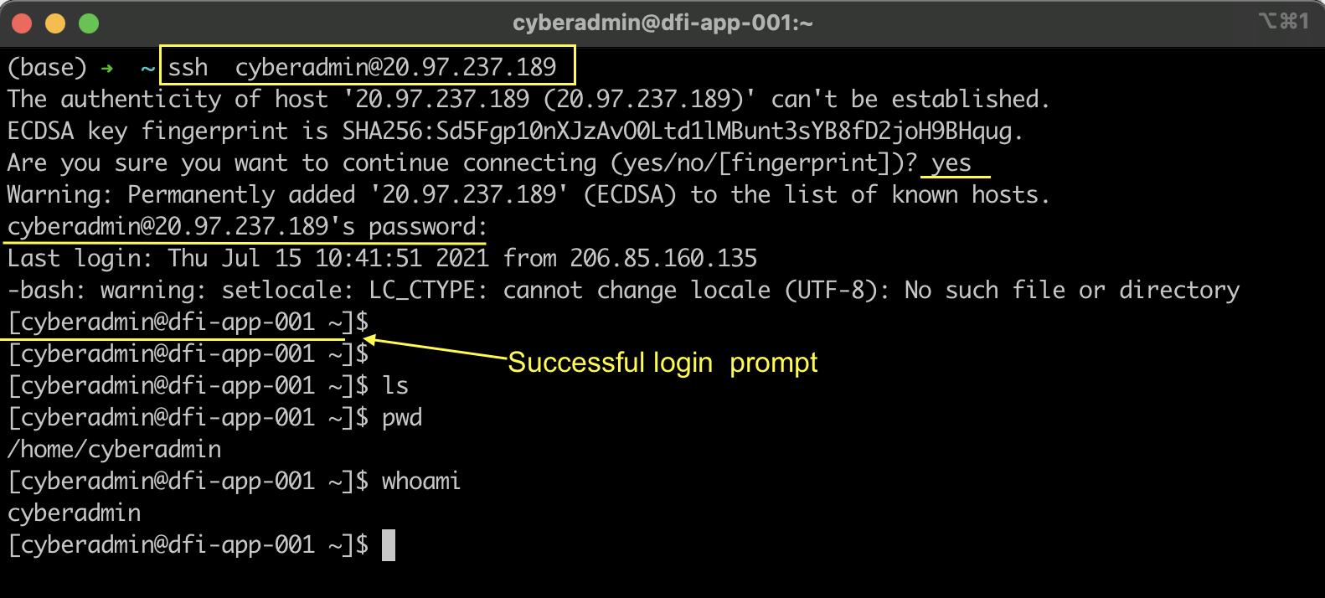
SSH login into the Cloud Lab
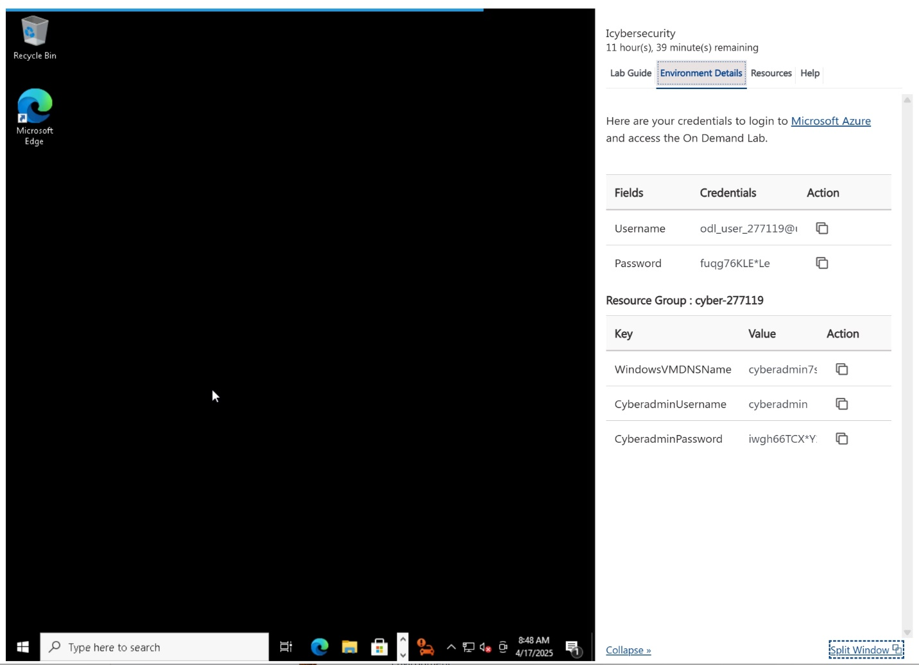
Environment Details in the Cloud Lab

Start the Cloud Lab VM
- Click on the ACCESS LAB button. Wait until the Cloud Lab loads (this could take up to 10 minutes)
- You can use the Cloud Lab VM in the classroom. For Linux VM's, start the lab and go to the Environment Details tab to get the SSH credentials for connecting from your local machine.
Tip: Access the Cloud Labs from an incognito browser to have a seamless experience.

Restrictions
- Cloud Labs session time is limited. Your session will expire after a certain hours, and you will lose all your resources in the temporary Azure account.
- Later, when you come back or refresh the Cloud lab page, you will get a new VM with a new pair of temporary credentials.
- You will not be able to create additional Resource Groups. There is one resource group already created for you named cloud-demo-XXXXXX. Choose the existing Resource Group when creating resources.
- You will not be able to create Active Directory resources. This is not a requirement for any project/exercise.
If you are not familiar with Azure, you can ignore the restriction points above.

Rubric
Use this project rubric to understand and assess the project criteria.

Connecting, Reporting and Analysis
Criteria | Submission Requirements
Demonstrate the ability to connect and navigate within the provided computing environment. | - Provide a screenshot showing a successful RDP connection to the Windows server.  - Ensure the Windows desktop or server interface is clearly visible.
Demonstrate understanding of security frameworks and best practices by analyzing the server's security configuration. | - Analyze C:\Departments\HR folder permissions and identify security issues.  - Provide recommendations for fixing the identified permission issues.  - Explain how your recommendations improve the security posture.  - Evaluate at least one server role and recommend whether to enable or disable it with justification.  - Identify at least two services that should remain running with justification for each.  - Identify at least two services that should be disabled with justification for each.
Demonstrate understanding of appropriate encryption methods for data in transit. | - Select an appropriate encryption method from the provided documentation.  - Provide 3-5 sentences justifying your encryption choice.
Demonstrate the ability to identify opportunities for security automation within an organization. | - Identify three areas where automation could enhance DFI's security posture.  - Provide specific automation recommendations for each identified area.

Firewalls and IDS Configuration
Criteria | Submission Requirements
Demonstrate understanding of firewall concepts and rule creation using proper syntax. | - Create Cisco access-list commands for both required scenarios.  - Ensure proper syntax and correct use of source/destination addresses and ports.  - Provide a 2-3 sentence explanation of the firewall rules for non-technical management.
Demonstrate understanding of intrusion detection concepts and rule creation. | - Create IDS rules for both scenarios using proper Snort syntax.  - Ensure unique SID numbers (1000000 or higher) for each rule.  - Include appropriate protocol, IP addresses, and ports as specified.  - Provide a 3-5 sentence explanation of the rules for non-technical management.
Demonstrate the ability to analyze firewall logs and recommend appropriate mitigation strategies. | - Analyze the provided DFI_FW_Report file for security concerns.  - Identify suspicious source IPs and recommend appropriate actions.  - Suggest additional protection layers for vulnerable services.  - Provide recommendations in 3-5 sentences with clear justification.

Encryption, Hashes and Linux
Criteria | Submission Requirements
Demonstrate the ability to verify file integrity using cryptographic hashes. | - Calculate the SHA256 hash of the specified file.  - Provide a screenshot showing both the command used and the resulting hash.  - Ensure the hash matches the provided reference value exactly.
Demonstrate understanding of Windows security event logging and analysis. | - Filter Windows Security logs for failed RDP attempts (Event ID 4625).  - Provide a screenshot of the Event Viewer with filtered results.  - Write a 3-5 sentence analysis of findings and security recommendations.  - Include an explanation even if no events are found.
Demonstrate understanding of Linux file system permissions and user management. | - Create the required directory structure under /home.  - Create all specified groups and users with proper group assignments.  - Set appropriate group ownership and permissions on directories.  - Provide screenshots demonstrating successful completion.  - Provide the commands that you used.  - Explain the syntax of commands used for directory and permission management.
Demonstrate the ability to communicate technical work to non-technical management. | - Summarize all completed security tasks in 6-8 sentences.  - Explain key security recommendations and their business impact.  - Present a cohesive narrative connecting all security improvements.  - Recommend at least two security products with justification.  - Recommend at least two security policies with justification.  - Maintain appropriate language for an executive-level audience.
Demonstrate understanding of file encryption for secure data transfer. | - Encrypt all project deliverables using 7zip with AES encryption.  - Create a strong password meeting complexity requirements (15+ characters).  - Provide the decryption password in the reviewer notes.

Suggestions to Make Your Project Stand Out
- When recommending automations, expand your recommendations beyond the areas explicitly listed.
- When reviewing Windows permissions suggest ways to streamline and centralize the ability to secure systems.
- In addition to reviewing failed RDP logins, include other recommendations using Syslog or a SIEM to centralize log aggregation. You'll need to provide explanations about why that should be considered.
- For your final report, provide a clear, thoughtful explanation understanding of the work that was performed and how it contributes to the organization.

Submission Details
After completing the project:
- Ensure that you have met all of the requirements of the Project Rubric. If you have not, please update your project before submission.
- Important: Compress the PDF report into a ZIP file with a password. When you submit your project, please remember to add this password in the notes for reviewer section or they will not be able to assess your project.
- Submit the zipped Defending and Securing Systems Project template on the Project Submission page.

